**Regular Falsi Method**

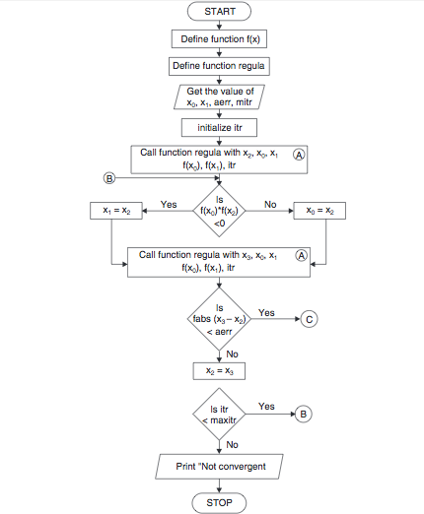

**Algorithm for Regular Falsi Method**

1. Start
2. Read values of x0, x1 and e(Here x0 and x1 are the two initial guesses, e is the degree of accuracy or the absolute error i.e. the stopping criteria)
3. Computer function values f(x0) and f(x1)
4. Check whether the product of f(x0) and f(x1) is negative or not.  
    a) If it is positive take another initial guesses.  
   b) If it is negative then goto step 5.
5. Determine:  
   x = [x0*f(x1) – x1*f(x0)] / (f(x1) – f(x0))
6. Check whether the product of f(x1) and f(x) is negative or not.  
   a) If it is negative, then assign x0 = x;  
   b) If it is positive, assign x1 = x;
7. Check whether the value of f(x) is greater than 0.00001 or not.  
   a) If yes, goto step 5.  
   b) If no, goto step 8.  
   (Here the value 0.00001 is the desired degree of accuracy, and hence the stopping criteria.)
8. Display the root as x.
9. Stop